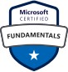
Azure SQL Server DBA 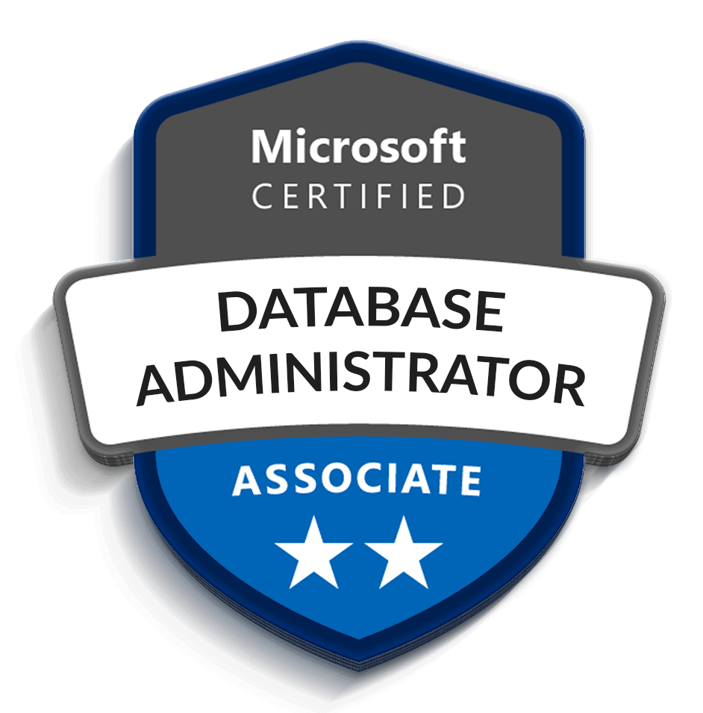
Venkat
Mob No: -+91-8088841870
E-mail: venkatazuresql@gmail.com
Notice Period: Immediately joining

PROFILE SUMMARY:
- Database Administrator with 8+ years of IT experience, including 5+ years of SQL Server DBA and Oracle DBA and 3 years of Azure SQL DBA experience. Expertise in database administration, Azure SQL Database, Azure SQL Managed Instance, performance tuning, High Availability (HA), Disaster Recovery (DR), backup and recovery, security, monitoring, and database migrations across BFSI, Healthcare, Finance & Banking, and E-commerce domains.
- Having experience with MS SQL Server DBA (2005,2008,2008R2, 2012 and 2014,2016,2017,2019,2022,2025) on Windows (2003,2008R2, 2012, 2014 & 2016,2019).
- Proven expertise in installation, configuration, maintenance, backup and recovery, replication, clustering, Always On, and disaster recovery across SQL Server versions 2005–2025 on Windows Server environments.
- Managed Azure SQL Databases and Azure SQL Managed Instances.
- Created databases based on application requirements, Configured firewall rules and virtual network access.
- Managed database users, roles, and permissions, Implemented Azure AD authentication.
- Experience in SQL Server development activities and schema comparison using Azure Data Studio.
- Resolving the Disk space issues and finding the root cause and permanent fixes.
- Expertise in Database backup, Recovery, Restoration and Disaster Recovery Plans.
- Configuring, maintaining, and troubleshooting the Database Log Shipping and experience in Mirroring, always on high availability, Transactional Replication.
- Worked in Migrating from SQL Server 2005,2008,2012, 2014, 2016 to 2017, 2019 by using In-Place upgrade process and side by side upgrade process and created the SOP for the Upgrade process.
- Experience in Creating SSIS packages, Scheduling Jobs, Sending Alerts using Database Mail.​
- Having knowledge in SQL Server Integration Service (SSIS) and SQL Server Report Service (SSRS) deployment, Client interaction during development, deployment, QA and production elevation phases.​
- Provide 24x7 DBA production support, work with DBA team for production on call support rotation as an individual contributor.
- Having knowledge on cloud migration activities and Devops database deployments
- Expertise in high availability (Always On, Clustering, Replication), disaster recovery, performance tuning, and database

TECHNICAL SKILL:
- Database Platforms : Microsoft SQL Server, PostgreSQL, MySQL, Snowflake (Basic)
- SQL Server Versions : SQL Server 2008 R2, 2012, 2014, 2016, 2017, 2019, 2022, 2025
- High Availability & DR : Always On Availability Groups, SQL Server Clustering, Database Mirroring, Log Shipping, Transactional Replication
- Backup & Monitoring Tools : Litespeed, Rubrik, Foglight
- Cloud environment : Microsoft Azure (IaaS, PaaS, Azure SQL, VM, Networking, Storage, Load Balancer), Azure Monitor, Query Store, Log Analytics, DMVs
- Data Integration : Azure Data Factory (ADF), SQL Server Integration Services (SSIS), SQL Server Reporting Services (SSRS)
- Operating Systems : Windows Server 2003, 2008 R2, 2012, 2014, 2016, 2019

EXPERIENCE DETAILS:
Azure Database Administrator – Crown Solutions (May 2024 – Jan 2025)
- Provided 24×7 DBA support ensuring SLA compliance for BFSI clients.
- Managed 15+ Azure SQL Databases in Production, UAT, and Development environments.
- Monitored Azure SQL performance using Azure Monitor, Query Store, and Log Analytics.
- Performed performance tuning by optimizing queries, rebuilding indexes, and updating statistics.
- Implemented High Availability using Auto Failover Groups and Geo-Replication.
- Managed Point-in-Time Restore (PITR) and backup validation.
- Configured Azure AD authentication, TDE, Dynamic Data Masking, and auditing.
- Resolved production issues involving blocking, deadlocks, high CPU, and storage utilization.
- Automated database health checks and reporting using PowerShell.
Database Administrator – Fidelity National Financial (FNFI) (Sep 2019 – Nov 2023)
- Managed HA/DR solutions including Log Shipping, Replication, Clustering, Always On.
- Conducted DR drills ensuring business continuity and resolved multiple security vulnerabilities
- Resolved performance bottlenecks, blocking, and deadlocks.
- Capacity planning and disk space monitoring across large enterprise databases.
- Performed performance tuning by optimizing queries, rebuilding indexes, and updating statistics.
- Implemented High Availability using Auto Failover Groups and Geo-Replication.
- Managed Point-in-Time Restore (PITR) and backup validation.
- Configured Azure AD authentication, TDE, Dynamic Data Masking, and auditing.
Analyst DBA – Datavail Infotech (Oct 2018 – Jul 2019)
- Installed and upgraded SQL Server environments (2005–2019).
- Performed migrations and refresh activities across Dev, QA, and Production.
- Automated administrative tasks using SQL Agent jobs and maintenance plans.
Service Desk Engineer – NISUM Technologies (Nov 2016 – May 2018)
- Provided L1 technical support for hardware, software, and network issues.
- Managed incidents using ServiceNow and JIRA with SLA adherence.
- Assisted with system upgrades, user onboarding, and access management

PROJECT DETAILS:
Key Projects
- American Family Insurance (AmFam):
  - Implemented HA/DR solutions (Always On, Clustering, Replication) and managed Azure SQL/ADF pipelines.
- American Express & United Health Group:
  - Delivered 24×7 DBA support, migrations, and performance tuning for financial systems.
- Shared Pool Environment (Healthcare, Finance, Marketing, Education):
  - Installed/configured SQL Server 2000–2019, applied patches, and tuned performance.
- Macy’s:
  - Provided L1 support, created SOPs, and ensured ITIL compliance.

Certifications:
- Microsoft Certified: Azure Fundamentals (AZ-900) and Azure database Administrator associate (DP-300)
- MCTS (70-432): SQL Server 2008 Implementation & Maintenance
- MCTS (70-462): SQL Server 2012 Databases

Education:
- Completed B. Tech (C.S.E) from Dr.M.G.R. Educational and University, Chennai.

Personal Details:
- Languages Known: English, Hindi and Kannada, Telugu, Tamil

Declaration:
- I hereby declare that the above furnished details are true to the best of my Knowledge.

(Venkat)

